Mammalian expression vectors
- SV40 based vector
Simian virus 40 (SV40) is a nonenveloped virus with an icosahedral capsid symmetry.
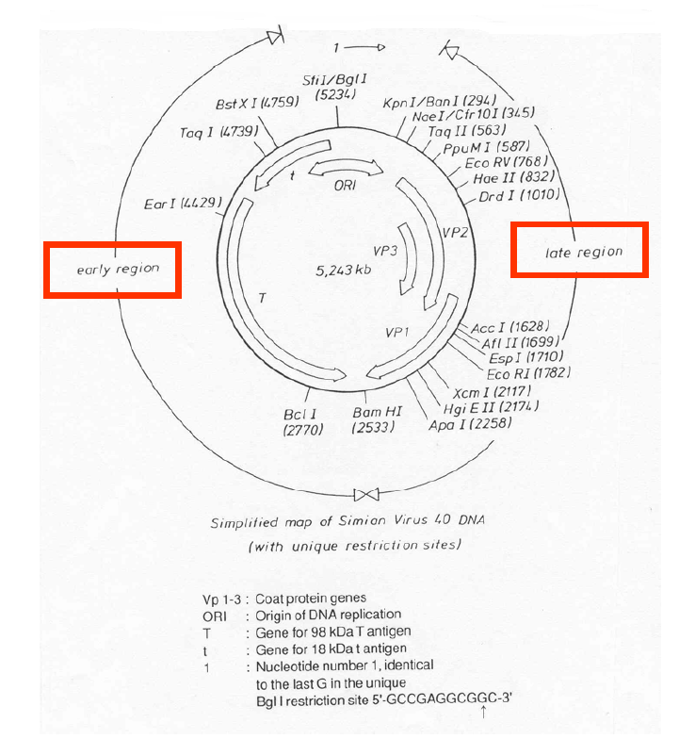
Figure: genetic map of the mammalian cell virus SV40
- SV40 large tumor antigen (T-ag) is involved in the initiation of viral replication in permissive hosts and regulates the expression of the late structural gene products that associate to form virions.
- The pSI Expression Vector contains the simian virus 40 (SV40) enhancer and early promoter region. This vector can be used for both transient and stable expression of genes. For stable expression, the pSI Vector must be co-transfected with an expression vector containing a selectable gene for mammalian cells.
- The pSI Mammalian Expression Vector promotes constitutive expression of cloned DNA inserts in most mammalian cells. The vector is maintained as an episome in cells expressing the SV40 large T antigen, leading to even higher levels of expression. A β-globin/IgG chimeric intron located downstream from the enhancer/promoter region can further increase expression. In addition, the late SV40 polyadenylation signal increases the steady-state level of RNA approximately fivefold more than the early SV40 polyadenylation signal.
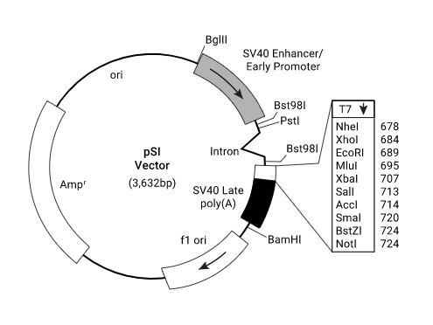
- Vaccinia virus-based vector
- The genome of vaccinia virus is made up of double stranded DNA of nearly 200,000 bp and replicates in the cytoplasm of the host cell. Cells infected with the vaccinia virus produces up to 5000 virus particles per cell, which leads to high levels of recombinant protein expression.
- The production and selection of infectious vaccinia virus recombinants expressing foreign genes was facilitated by the construction of plasmid vectors. These vectors contain all or part of the vaccinia virus thymidine kinase (TK) gene interrupted by multiple unique restriction endonuclease sites placed adjacent to the TK promoter or another promoter translocated within the TK gene.
- The insertion of a continuous coding sequence for a foreign protein at one of the unique restriction endonuclease sites places side by side the transcriptional start site of a vaccinia promoter and the translational start site of a foreign gene.
- After transfection of vaccinia virus-infected cells with such plasmids, homologous recombination occurs between the vaccinia virus sequences flanking the chimeric gene and the same sequences within the virus genome.
- Recombinants formed in this manner have the chimeric gene inserted within the body of the vaccinia virus TK gene under control of a vaccinia virus promoter. Since recombinants have an interrupted TK gene, they are selected on the basis of their TK- phenotype and then checked for the presence and expression of the foreign gene.

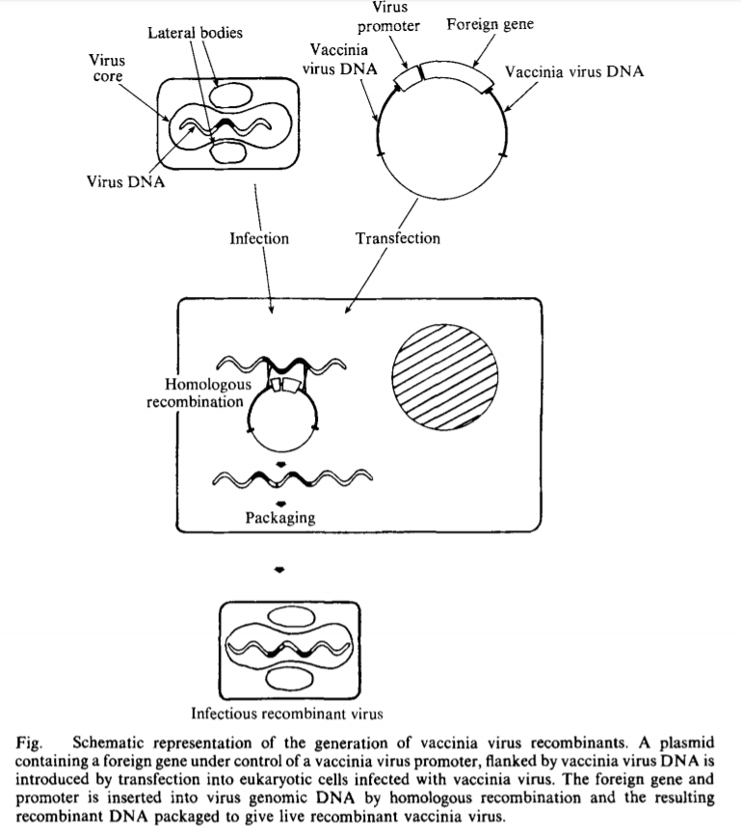
- Retroviral promoter-based vectors
- A retrovirus is any virus belonging to the viral family Retroviridae. All The genetic material in retroviruses is in the form of RNA molecules, while the genetic material of their hosts is in the form of DNA. When a retrovirus infects a host cell, it will introduce its RNA together with some enzymes into the cell. This RNA molecule from the retrovirus must produce a DNA copy from its RNA molecule before it can be considered part of the genetic material of the host cell. Retrovirus genomes commonly contain these three open reading frames that encode for proteins that can be found in the mature virus. Group-specific antigen (gag) codes for core and structural proteins of the virus, polymerase (pol) codes for reverse transcriptase, protease and integrase, and envelope (env) codes for the retroviral coat proteins.
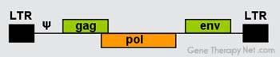
- The only retroviral elements required in cis are the two long terminal repeats (LTRs), the packaging site (ψ), and the reverse transcription initiation sites found in the terminal portions of the provirus. The 5′ LTR acts as the promoter and enhancer while the 3′ LTR contains the poly-A signals, both are necessary for transcription of the retroviral mRNA. The ψ site located just downstream of the 5′ LTR is the binding site for the gag polyprotein which packages the RNA into the viral core. These cis-acting elements need to be included in all retroviral vector designs.
- Retroviral vectors are created by removal of the retroviral gag, pol, and env genes. These are replaced by the therapeutic gene. In order to produce vector particles a packaging cell is essential. Packaging cell lines provide all the viral proteins required for capsid production and the virion maturation of the vector. These packaging cell lines have been made so that they contain the gag, pol and env genes. Early packaging cell lines contained replication competent retroviral genomes and a single recombination event between this genome and the retroviral DNA vector could result in the production of a wild type virus. Following insertion of the desired gene into in the retroviral DNA vector, and maintenance of the proper packaging cell line, it is now a simple matter to prepare retroviral vectors.
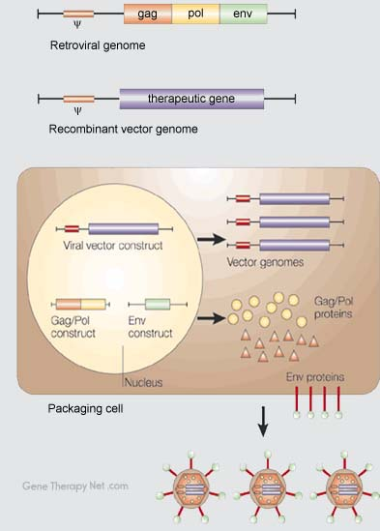
- An example of retroviral promoter based vector is pBABE-puro.

